IRSDEPARTMENT OF THE TREASURY

INTERNAL REVENUE SERVICE

CINCINNATI OH 45999-0023

Date of this notice: 01-30-2020

Employer Identification Number: 84-4518315

Form: SS-4



Number of this notice : cp 575 E

MINORITY EMPOWERPIENT NETWORK INC

10460 QUEENS BLVD APT 7C

FOREST HILLS, NY 11375 For assistance you may call us at-'

# 1-800-829-4933

IF YOU WRITE, ATTACH THE

STUB AT THE END OF NOTICE.

WE ASSIGNED YOU EMPLOYER IDENTIFICATION NUMBER

Thank you for applying for an Employer Identification Nurrtber (EIN) . (Ne assxgned you EIN 84-4518315. This EIN will identify you, your business accounts, tax returns, and documents, even if you have no employees . Please keep this notice in your permanenc records .

When filing tax documents, payments, and related correspondence, it is very

Important that you use your EIN and complete name and address exactly as shown above. Any variation may cause a delay in processing, result in incorrect information in your account, or even cause you to be assigned more than one EIN. If the information is not correct as shown above, please make the correction using the attached tear—off stub and return it to us.

When you submitted your application for an ET-Nf you checked the box indicating you are a non—profit organization. Assigning an EIN does not grant tax—exempt status to non—profit organizations . Publication 557 r Tax—Exempt Status for Your Organization, has details on the application process, as well as information on returns you may need to file. To apply for recognition of tax—exempt status under Internal Revenue Code Section 501 (c) (3) , organizations must complete a Form

1023—series application for recognition. All other entities should file Form 1024 if to request recognition under Section 501 (a.) .

Nearly all organizations claiming tax—exempt status must file a Form 990—series annual information return (Form 990, 990—EZ, or 990—PF) or notice (Forrtü990=N beginning with the year they legally form, even if they have not yet applied for or received recognition of tax—exempt status .

Unless a filing exception applies to you (search www.irs . gov for Annual Exempt Organization Return: Who Must File) you will lose your tax—exempt status if you fail to file a required return or notice for three consecutive years . We start calculating this three—year period from the tax year we assigned the EIN to you. If that first tax year isn't a full twelve months, you re still responsible for submitting a return for that year . If you didn't legally form in the same tax year in which you obtained your EIN, contact us at the phone nurnber or address listed at the top of this letter .

For the most current information on your filing requirements and other important information, visit www.irs . gov/ charities .

(IRS USE ONLY) 575E 01-30-2020 MINO o 9999999999 SS-4

IMPORTANT REMINDERS :

Keep a copy of this notice in your permanent records. This notice is issued only one tiltE and the IRS will not be able to generate a duplicate copy for you. You may give a copy of this document to anyone asking for proof of your EIN.

* Use this EIN and your name exactly as they appear at the top of this notice on all your federal tax forms .

* Refer to this EIN on your tax—related correspondence and documents.

 Provide future officers of your organization with a copy of this notice .

Your name control associated with this EIN is MINO. You will need to provide this information, along with your EIN, if you file your returns electronically.

If you have questions about your EIN, you can contact us at the phone number or address listed at the top of this notice. If you write, please tear off the stub at



the bottom of this notice and include it with your letter. Thank you for your cooperation.

Keep this part for your records . C? 575 E (Rev. 7-2007)

|  |  |
| --- | --- |
| Return this part with any correspondence |  |
| so we may identify your account. Please correct any errors in your name or address. | CP 575 E |

9999999999

Your Telephone Number Best Time to Call DATE OF THIS NOTICE: 01-30-2020

EMPLOYER IDENTIFICATION  84-4518315

FORM: SS-4 NOBOD

INTERNAL REVENUE SERVICE MINORITY EMPOWERMENT NETWORK INC

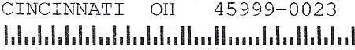 CINCINNATI OH 10460 QUEENS BLVD APT 7C

FOREST HILLS, NY 11375

Department of the Treasury

Internal Revenue Service

Tax Exempt and Government Entities

IRS P.O. Box 2508

Cincinnati, OH 45201

MINORITY EMPOWERMENT NETWORK INC

C/O SHYAM KARKI

75-22 37TH AVE APT65

JACKSON HEIGHTS, NY 11372



Dear Applicant:

Date:

11/05/2021

Employer ID number:

84-4518315

Person to contact:

Name: Customer Service ID number: 31954 Telephone: 877-829-5500 Accounting period ending:

December 31

Public charity status:

Form 990 1990-EZ/ 990-N required:

Effective date of exemption: Januarv 22, 2020

Contribution deductibility:

Yes

Addendum applies:

No

DLN:

26053635003961

We're pleased to tell you we determined you're exempt from federal income tax under Internal Revenue Code (IRC) Section 501(c)(3). Donors can deduct contributions they make to you under IRC Section 170. You're also qualified to receive tax deductible bequests, devises, transfers or gifts under Section 2055, 2106, or 2522. This letter could help resolve questions on your exempt status. Please keep it for your records.

Organizations exempt under IRC Section 501 (c)(3) are further classified as either public charities or private foundations. We determined you're a public charity under the IRC Section listed at the top of this letter.

If we indicated at the top of this letter that you're required to file Form 990/990-EZ/990-N, our records show you're required to file an annual information return (Form 990 or Form 990-EZ) or electronic notice (Form 990-N, the e-Postcard). If required return or notice for threæconyecutive years, your exempt status will be autoaatically revoked.



If we indicated at the top of this letter that an addendum applies, the enclosed addendum is an integral part of this letter.

For important information about your responsibilities as a tax-exempt organization, go to www.irs.gov/charities. Enter "4221-PC' in the search bar to view Publication 4221-PC, Compliance Guide for 501 (c)(3) Public Charities, which describes your recordkeeping, reporting, and disclosure requirements.

Sincerely,



Stephen A. Martin

Director, Exempt Organizations

Rulings and Agreements

Letter 947 (Rev. 2-2020)

Catalog Number 35152P



# N. Y. S. DEPARTMENT OF STATE DIVISION OF CORPORATIONS AND STATE RECORDS ALBANY , 12231-0001

FILING RECEIPT

ENTITY NAME: MINORITY EMPOWERMENT NETWORK INC

# DOCUMENT TYPE: INCORPORATION (NOT-FOR-PROFIT) TYPE : C COUNTY: QUEE



# FILER : EXIST DATE





SHYAM KUMAR KARRKI 01/22/2020 3988 49TH STREET # 5H

SUNNYSIDE, NY 11104

ADDRESS FOR PROCESS:

# SHYAM KUMAR 5101 39TH AVENUE #G21 SUNNYSIDE, NY 11377

REGISTERED AGENT :

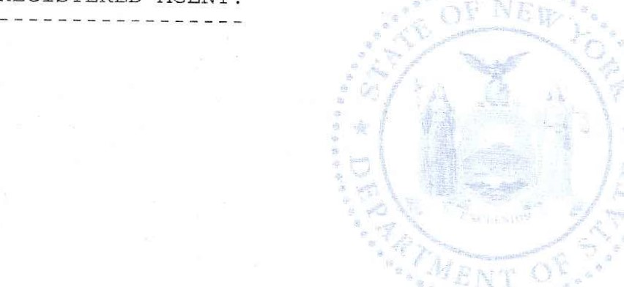





SERVICE COMPANY: ** NO SERVICE COMPANYSERVICE CODE:

FEES 110 . 00 PAYMENTS 110 . 00





|  |  |  |  |
| --- | --- | --- | --- |
| FILING | 75 . 00 | CASH | 0 . 00 |
| TAX | 0 . 00 | CHECK | o. co |
| CERT | 0 . 00 | CHARGE | 110 . 00 |
| COPIES | 10 00 | DRAWDOWN | o. co |
| HANDLING | 25 . 00 | OPAL | o 00 |
|  |  | REFUND | 0 . 00 |

DOS-1025 (04/2007 )

# STATE OF NEW YORK

DEPARTMENT OF STATE

I hereby certify that the annexed copy has been compared with the original document in the custody of the Secretary of State and that the same is a true copy of said original.

WITNESS my hand and official seal of the Department of State, at the City of Albany, on January 23, 2020.

Brendan C. Hughes

Executive Deputy Secretary of State

Rev. 06/13

